Year 12 ATAR Homeostasis
Describe the steps of negative feedback system and compare with a positive feedback system.
The steps of a stimulus-response feedback model
- Stimulus- Change to environment
- Receptor (sends a message)- Stimulus detected by sensory cells
- Modulator- Control centre interprets the message
- Effector- Muscle/gland that receives pain message
- Response- Muscle/gland that reacts to message
- Feedback- Positive or negative and why?
Negative feedback- The response is trying to prevent the stimulus from continuing to occur E.g —> When the body temperature is too high
Positive feedback- The response is trying to encourage the stimulus to continue on
E.g —> During labor contractions need to continue to occur

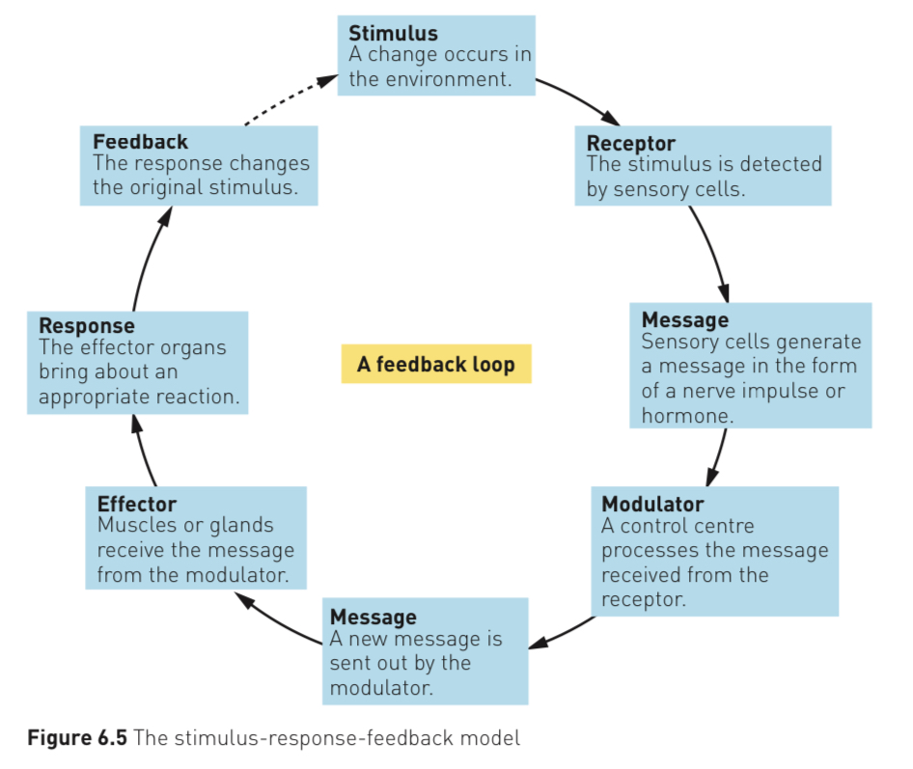
Draw a diagram of a negative feedback loop showing the components.

Explain how nerves and hormones contribute to maintaining homeostasis.
Nerves
Thermoreceoptors- Respond to heat and cold
- Receptors are nerve endings in skin that alerts brain to changes in temperature outside the body, sense hot/cold
- Information is received by the hypothalamus
- Internal temperature is monitored by thermoreceptors in the hypothalamus
Osmoreceptors- Detect osmotic pressure
- Stimulated by changes in concentration of dissolved substances in water
- Located in the hypothalamus
- Is very sensitive
Touch receptors- Are close to surface of skin and are sensitive to touch, light and vibrations
- Surface receptors occur in lips, fingertips, eyelids and external genitals
- Deeper receptors detect pressure and vibrations
Pain receptors- Responds to damaged tissues/excessive stimulation from heat/chemicals
- Located in most organs except brain
- Mostly in skin/mucus membranes
- Receptors rarely adapt so body will respond and try stop the pain response from happening
- Pain is essential for wellbeing and alerts body to damage
Hormones
Blood sugar- regulated by glucose, glycogen, insulin and glucagon
Glucose- Sugar used in respiration to make energy
Insulin- Hormone that tells body to convert glucose to glycogen and it—>made by the pancreas. Is released when blood sugar levels are too high.
Glucagon- Hormone that tells liver to change glycogen back to glucose—> made by the pancreas. Is released when blood sugar levels are too low.
Fluid balance- Water is 60% of our bodies and need to be maintained to keep homeostatic balance, it’s controlled by the kidneys via…
Anti-diuretic hormone (ADH)- This will be released by the posterior pituitary when there’s too little water concentration
- Will increase permeability of the kidney collecting duct so more water will get absorbed into the body
Aldosterone- Acts on the distal tubules and collecting ducts of the nephron and causes the conservation of sodium ions and secretion of potassium ions
Diabetes- Body is unable to produce/doesn’t respond to insulin which can cause hyperglycaemia

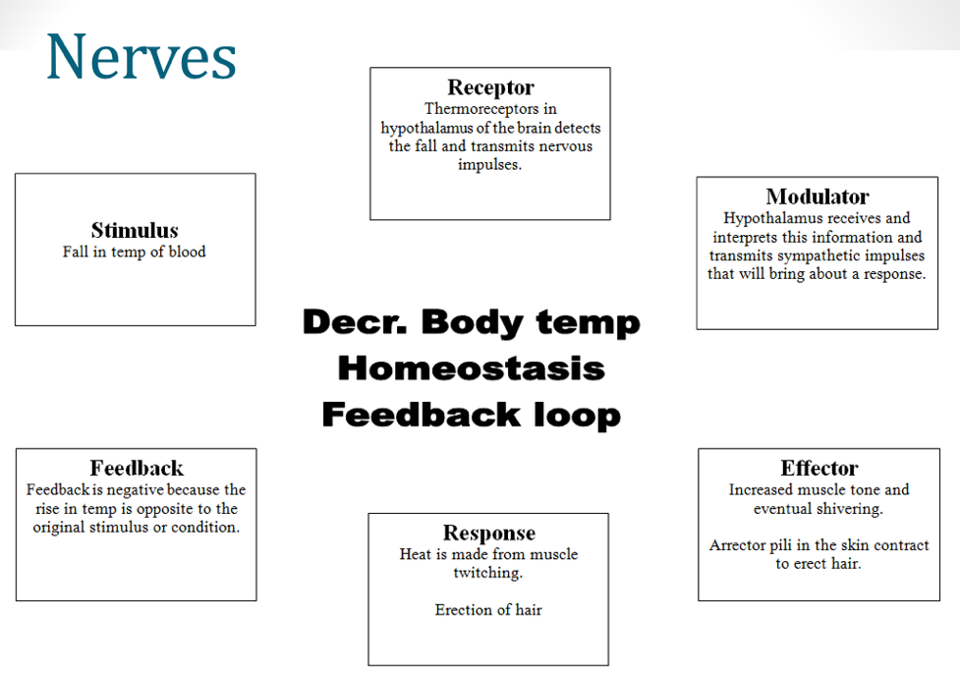
Draw a feedback loop for thermoregulation, identify stimulus, receptor, modulator, effector and responses.

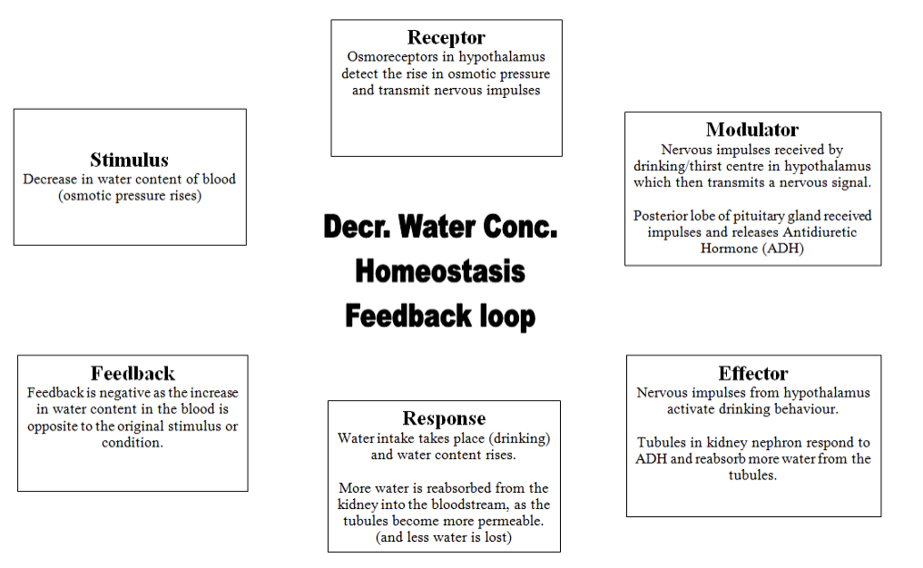
Draw a feedback loop for fluid concentration, identify stimulus, receptor, modulator, effector and response.

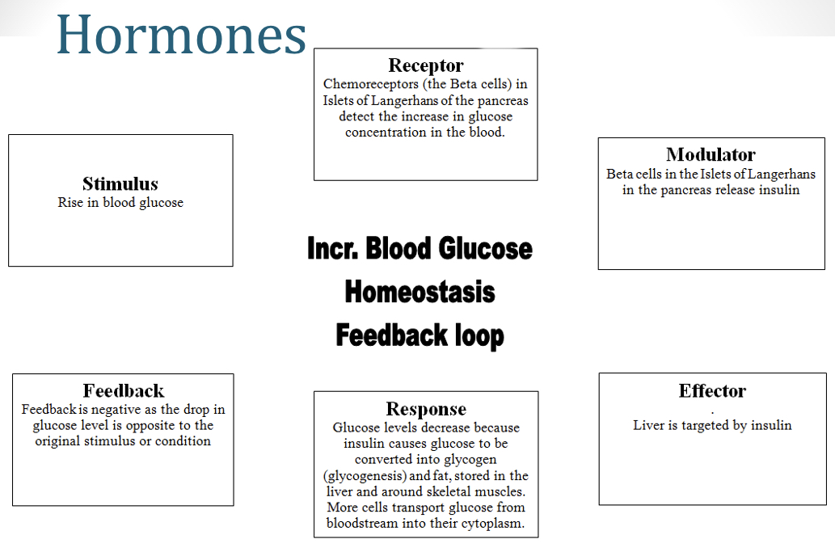
Draw a feedback loop for blood sugar levels identify stimulus, receptor, modulator, effector and response.

Draw a feedback loop for gas concentration identify stimulus, receptor, modulator, effector and response.
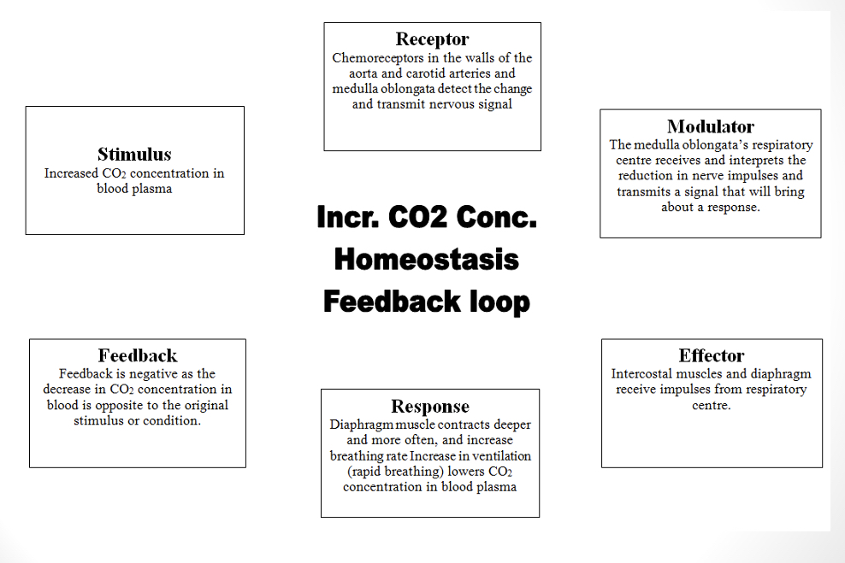
Describe how synthetic hormones are used to treat endocrine dysfunctions such a diabetes.
- Synthetic insulin can help regulate blood sugar
- Insulin can be injected to assist with storing glucose to glycogen to lower blood sugar

